**The Making of The Room (Tuesday 20th November, 2012)**

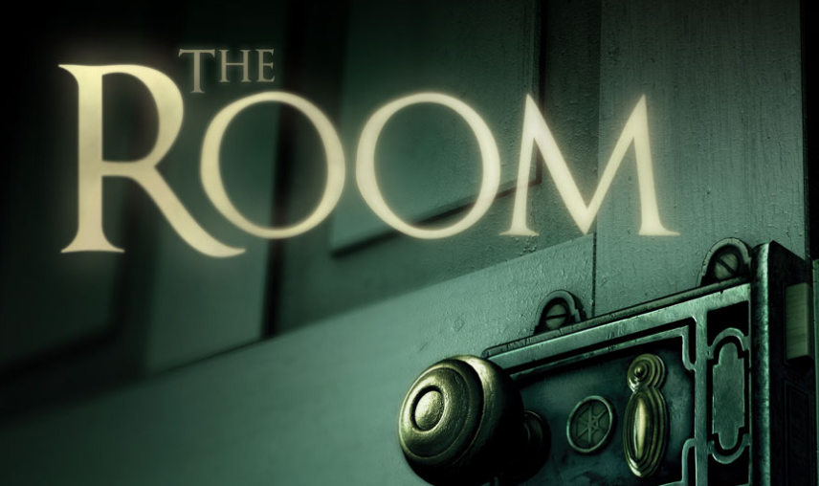

Fall into a world of bizarre contraptions and intricate machinery with The Room, the BAFTA award-winning 3D puzzler from Fireproof Games, now beautifully rebuilt and remastered for PC and Nintendo Switch. Following a trail mysterious letters, you find yourself entangled in a journey shrouded with secrets and deception. Trapped with only an elaborate puzzle box, you must delve into the unknown using only your wits to unlock the answers you desperately seek. Solve intricate and unique challenges to make a series of puzzle boxes transform and unfold before your eyes in an enthralling combination of myth and machinery. Use an ornate eyepiece to uncover hidden messages, decipher codes and unlock sophisticated mechanisms, stepping you closer to the truth behind the cryptic letters that led you here while pulling you deeper into the mysteries of The Room.

-Features

REALISTIC GRAPHICS

The most unsettlingly realistic and natural looking visuals ever seen on a mobile device.

IMMERSIVE GAMEPLAY

Innovative gameplay which consumes the player in the mysterious world of The Room.

ONE TOUCH CONTROL

Intuitive controls so natural you can play with one digit, to fully navigate this mysteriously beautiful 3D world.

PICK UP & PLAY DESIGN

Easy to start, hard to put down, the secrets of The Room will immerse you before you even know you’re playing.

COMPELLING MYSTERY

An intriguing story revealed in layers; think you know what you’re looking at? Think again.

SPINE TINGLING SOUND

Hauntingly beautiful audio which really draws you in; playing with headphones strongly recommended.

